Type of Document | How to Name | What date to use
Letter to opposing attorney | YEAR-MO-DA LT OPA re (brief summary of content)* | Date letter was served/sent
Letter from opposing attorney | YEAR-MO-DA LF OPA re (brief summary of content) | Date indicated on letter
Letter to Court Admin/Judge (from us) | YEAR-MO-DA LT Judge re (brief summary of content)** | Date letter was filed/sent
Letter to Court Admin/Judge (from OPA) | YEAR-MO-DA LF OPA to Judge re (brief summary of content) | Date letter was filed/sent
Letter to opposing party | YEAR-MO-DA LT OPP re (brief summary of content) | Date letter was sent
Letter from opposing party | YEAR-MO-DA LF OPP re (brief summary of content) | Date letter was received
Letter to Client | YEAR-MO-DA LT Client re (brief summary of content) | Date letter was sent
*If letter is prepared by us and eserved on another party, save the eserved version to file (delete original version) and indicate (ESERVED) behind the name
Example: 2023-12-26 LT OPA re settlement offer (ESERVED)

**If letter is prepared by us and efiled with court, save the efiled version to the file (delete original version) and indicate (EFILED) behind the name. If the letter was also eserved on another party (generally OPA), also indicate (ESERVED) behind the name.
Example 2023-12-26 LT Judge re motion hearing (EFILED ESERVED)

Date Discrepancies (USPS): If a letter is received on a different date than the date on the letter, note in name. This generally pertains to letters received via USPS and helps to clarify when we actually received the letter as it can be quite different than the actual date of the letter.
Example: 2023-12-18 LF OPA re discovery request (received 12.26.23)
DRAFTS – for the draft version of any document add “DRAFT (your initials lowercase) after the date (Ex: 2025-08-05 DRAFT bf LT OPA re mediation; 2025-08-10 DRAFT js Cert of Rep; 2025-07-21 DRAFT aa Stip and Proposed Order; 2025-07-01 DRAFT bf NOMM, 2025-06-10 DRAFT js LT Court re Motion) CORRESPONDENCE
DOCUMENTS
Type of Document | How to Name | What date to use
Initial Intake completed by client | YEAR-MO-DA – Intake | Date intake submitted
Invoices from vendors | YEAR-MO-DA – Invoice from xxxx” | Date of invoice
Retainer Agreement | YEAR-MO-DA – Retainer Agreement (signed) | Date of client’s signature
Authorization to Share Information | YEAR-MO-DA – Autho to Share (signed) | Date of client’s signature
NOTICES
Type of Document | How to Name | What date to use
Notice of Case Filing and Assignment | YEAR-MO-DA (title) | Date notice was filed by Court | NOCF
Notice of Judicial Assignment | YEAR-MO-DA (title) | Date notice was filed by Court | NOJA
Notice of Hearing | YEAR-MO-DA (title) | Date notice was filed by Court | NOH
Notice of Remote Zoom Hearing | YEAR-MO-DA (title) | Date notice was filed by Court | NORZH
Notice of Filing of Order (and entry of judgement) filed by Court | YEAR-MO-DA Ct’s (title) | Date notice was filed by Court | NOFO
Notice of Filing of Order (drafted by us) | YEAR-MO-DA Our (title) | Date we filed w/ court | NOFO
Notice of Filing of Order (drafted by OPA) | YEAR-MO-DA OPA (title) |  | NOFO
ORDERS
Type of Document | How to Name | What date to use | Common Abbreviations
Notice of Judicial Determination | YEAR-MO-DA (title) | Date notice was filed by Court | NOJD
Summary Real Estate Disposition Judgement | YEAR-MO-DA (title) | Date order was filed by Court | SREDJ
Qualified Domestic Relations Order | YEAR-MO-DA (title) | Date order was signed by Judge | QDRO
Proposed Order (drafted by us)  *these documents will NOT be signed by a Judge and may include both a WORD and PDF version | YEAR-MO-DA Proposed Order | Date we filed w/ court
Proposed Order (drafted by OPA)  *these documents will NOT be signed by a Judge and may include both a WORD and PDF version | YEAR-MO-DA OPA Proposed Order | Date we filed w/ court
Certificate of Dissolution | YEAR-MO-DA Cert of Diss | Date order was signed by Judge
Order* | YEAR-MO-DA (title) | Date order was signed by Judge
*Orders have a lot of different names based on the situation. Some examples may include:
-Order for Temporary Relief -Order for Child Support -Order regarding Custody and Parenting Time -Order for ICMC
-Order following ICMC -Order removing Judge -Scheduling Order -Order Waiving ICMC
-Order for Parent Education -Order Appointing Custody Evaluator/Parenting Time Expeditor
-ExParte Order -Order Appointing Guardian ad Litem (GAL) -Order granting Continuance

*There are certain orders that have fairly long names, usually something like “Combined Marital Termination Agreement, Finding of Fact, Conclusion of Law, Order for Judgement, Judgement and Decree for Dissolution of Marriage” |  | Date Order was signed by Judge | We often abbreviate that as MTA (Marital Termination Agreement), but you may also see other abbreviations like FOF (Findings of Fact), COL (Conclusion of Law), OFJ (Order for Judgement), J&D (Judgment and Decree)
KEEPING YOUR ORDERS FILE ORGANIZED
- Make sure draft versions are in the draft folders
- If you get an updated version of an order you are working on, move the older versions into drafts
- As you get an order signed, delete the unsigned or “less signed” versions. For instance:
  - You start with an unsigned MTA in PDF.
  - You get our client’s signature, delete the unsigned PDF version.
  - Once you get the OPA/OPP’s signature on the MTA, delete the PDF version that only has our client’s signature.
  - Once you file the MTA, save the efiled version to the file and indicate (EFILED ESERVED) behind the name (or just EFILED if ESERVED is not applicable), then delete the previous PDF that had all the parties signatures.
  - Finally, when you get the copy signed by the Judge, delete the EFILED version.

PLEADINGS
Type of Document | How to Name | What date to use | Common Abbreviation
Summons (drafted by us) | YEAR-MO-DA Summons | Date signed by attorney
Summons (from OPP/OPA) | YEAR-MO-DA OPA Summons | Date signed by OPP/OPA
Petition (drafted by us) | YEAR-MO-DA Petition | Date signed by client
Petition (from OPP/OPA) | YEAR-MO-DA OPA Petition | Date signed by OPP/OPA
Answer & Counter Petition (drafted by us) | YEAR-MO-DA Answer & CP | Date signed by client | A & CP
Answer & Counter Petition (from OPA) | YEAR-MO-DA OPA Answer & CP | Date signed by OPP/OPA
Certificate of Representation (drafted by us) | YEAR-MO-DA Cert of Rep | Date signed by attorney | COR
Certificate of Representation (from OPA) | YEAR-MO-DA OPA Cert of Rep | Date signed by OPP/OPA | COR
Confidential Information Form (drafted by us) | YEAR-MO-DA Conf Info Form | Date signed by attorney
Confidential Information Form (from OPA) | YEAR-MO-DA OPA Conf Info Form | Date signed by OPP/OPA
Acknowledgement/Admission of Service (signed by OPP) | YEAR-MO-DA Ack of Service (signed by OPP) | Date signed by OPP
Acknowledgement/Admission of Service (signed by our client) | YEAR-MO-DA Ack of Service (signed by client) | Date signed by client
Affidavit of Personal Service | YEAR-MO-DA Affidavit of Personal Service | Date service was completed
Scheduling Statement (drafted by us) | YEAR-MO-DA Scheduling Statement | Date we filed w/ court | Sch Stmt
Scheduling Statement (drafted by OP) | YEAR-MO-DA OPA Scheduling Statement | Date served/filed by OPA | Sch Stmt
Affidavit (drafted by us) | YEAR-MO-DA Affidavit of (name) | Date signed by client | Aff
Affidavit (from OPA) | YEAR-MO-DA OPA Affidavit of (name) | Date served/filed by OPA
Notice of Motion and Motion (drafted by us) | YEAR-MO-DA Notice of Motion and Motion for (brief description) | Date signed by attorney | NOMM
Notice of Motion and Motion (from OPA) | YEAR-MO-DA OPA Notice of Motion and Motion (brief description) | Date served/filed by OPA | NOMM
Exhibits accompanying affidavit (our affidavit) | YEAR-MO-DA Exhibit (#) | Date we filed w/ court
Exhibits accompanying affidavit (OPA affidavit) | YEAR-MO-DA OPA Exhibit (#) | Date served/filed by OPA
Certificate of Settlement Efforts (drafted by us) | YEAR-MO-DA Cert of Set Efforts | Date we filed w/ court | 303 notice
Certificate of Settlement Efforts (drafted by OPA) | YEAR-MO-DA OPA Cert of Set Efforts | Date served/filed by OPA | 303 notice
Memorandum of Law (drafted by us) | YEAR-MO-DA Memo of Law | Date we filed w/ court | MOL
Memorandum of Law (from OPA) | YEAR-MO-DA OPA Memo of Law | Date served/filed by OPA | MOL
Initial Case Management Conference Data Sheet (drafted by us) | YEAR-MO-DA ICMC Data Sheet | Date signed by attorney | ICMC
Initial Case Management Conference Data Sheet (from OPA) | YEAR-MO-DA OPA ICMC Data Sheet | Date served/filed by OPA | ICMC
Request for Continuance (drafted by us) | YEAR-MO-DA Request for Continuance | Date we filed w/ court
Request for Continuance (drafted by OPA) | YEAR-MO-DA OPA Request for Continuance | Date served/filed by OPA
Parenting/Financial Disclosure Statement | YEAR-MO- DA Par Fin Disc Stmt |  | PFDS
Copy Request | YEAR-MO-DA Copy Request | Date we filed w/ court
Withdrawal of Attorney | YEAR-MO-DA (OPA or Our) Withdrawal | Date filed w/ court
KEEPING YOUR PLEADINGS FILE ORGANIZED
- Make sure draft versions are in the draft folders
- Once you get a signed version of a pleadings, move the unsigned version to drafts or delete
- Once you file a pleadings, save the efile/eserved version (the one that is stamped from the Court), label it as such, and delete the prior version.
  - For instance:
    - You start with an unsigned Petition in PDF
    - You get our client’s signature on the Petition, save that to Pleadings, and delete the unsigned version.
    - You then file the Petition and receive back from Odyssey a copy that is stamped by the Court, indicating it was Efiled/Eserved. Save the efiled version to the file and indicate (EFILED ESERVED) behind the name (or just EFILED if ESERVED is not applicable), then delete the previous PDF that is not stamped, doesn’t indicate it was filed.

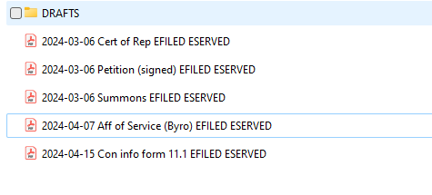
This is how your pleadings file should look if you EFILED AND ESERVED OR like this if you just EFILED because there’s no OPA
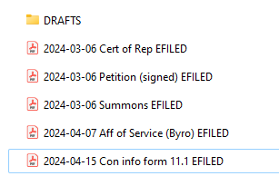
This is no good
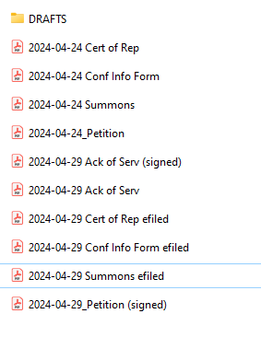
There are multiple versions of document which should not be the case
- Some appear to have been efiled and some aren’t. Confirm which are efiled, make sure they are the stamped version, and delete the other copy
- There are signed versions of a petition and then another one that appears to not be signed. Delete the unsigned version. Same with the Ack of Serv.

DISCOVERY

Type of Document | How to Name | What date to use | Common Abbreviations
(Petitioner’s/Respondent’s) Interrogatories to (Petitioner/Respondent) Drafted by us | YEAR-MO-DA Our Interr to OPA  *This should be saved in a new folder within Discovery titled “Our Requests to Them” | Date we serve the document on OPA | Interr, Rogs
(Petitioner’s/Respondent’s) Interrogatories to (Petitioner/Respondent) Drafted by OPA | YEAR-MO-DA OPA Interr Requests  *This should be saved in a new folder within Discovery titled “Their Requests to Us” | Date the document was served on us | Interr, Rogs
(Petitioner’s/Respondent’s) Request for Production of Documents to (Petitioner/Respondent) Drafted by us | YEAR-MO-DA Our RPD to OPA  *This should be saved in a new folder within Discovery titled “Our Requests to Them” | Date we served the document on OPA | RPD, RFPD
(Petitioner’s/Respondent’s) Request for Production of Documents to (Petitioner/Respondent) Drafted by OPA | YEAR-MO-DA OPA RPD  *This should be saved in a new folder within Discovery titled “Their Requests to Us” | Date the document was served on us | RPD, RFPD
(Petitioner’s/Respondent’s) Answers to Interrogatories (Drafted by us) | YEAR-MO-DA Our Answers to OPA Interrogatories  *This should be saved in a folder within Discovery titled “Their Requests to Us” | Date signed by our client | Interr, Rogs
(Petitioner’s/Respondent’s) Answers to Interrogatories (Drafted by OPA) | YEAR-MO-DA OPA Answers to Interr  *This should be saved in a folder within Discovery titled “Our Requests to Them” | Date received from OPP/OPA | Interr, Rogs
(Petitioner’s/Respondent’s) Response to RPD (Drafted by us) | YEAR-MO-DA Our Response to OPA RPD  *This should be saved in a folder within Discovery titled “Their Requests to Us” | Date signed by our client | RPD, RFPD
(Petitioner’s/Respondent’s) Response to RPD (Drafted by OPA) | YEAR-MO-DA OPA Response to RPD  *This should be saved in a folder within Discovery titled “Our Requests to Them” | Date received from OPP/OPA | Interr, Rogs

When referring to the “stamped” version, or the EFILED/ESERVED version of a document, this is version we are talking about and what you should receive in an email from Odyssey after filing

EFILED AND EFILED/ESERVED
Will have the file number in the middle and also say filed with the date and time in the upper right
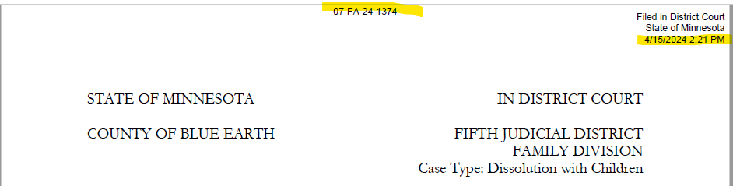

ESERVED ONLY
Will have the file number in the middle and also electronically served with the date and time in the upper left corner

