Calendaring

Key Points for all calendaring
- Always choose the case in “Case or Lead”
- Select only our client under contacts and leads (Click BOTH Share and Attend)
- Only select the attorney under staff (Click BOTH Share and Attend)
- Always include zoom instructions in the description (if applicable) and double check

Client Meeting = Green
Potential Client = Purple

Court = Red
Mediation/ENE = Orange

Staff Meeting = Brown
Travel Time = Cream
Do Not Schedule = Pink

Court Hearings
- All uppercase
- Always book for an hour unless it is a trial, evidentiary hearing, or you are told otherwise
- If the hearing is in person versus zoom put (IN PERSON) behind the title and select appropriate location
  - For instance, MCTESTERSON - MOTION HEARING (IN PERSON)
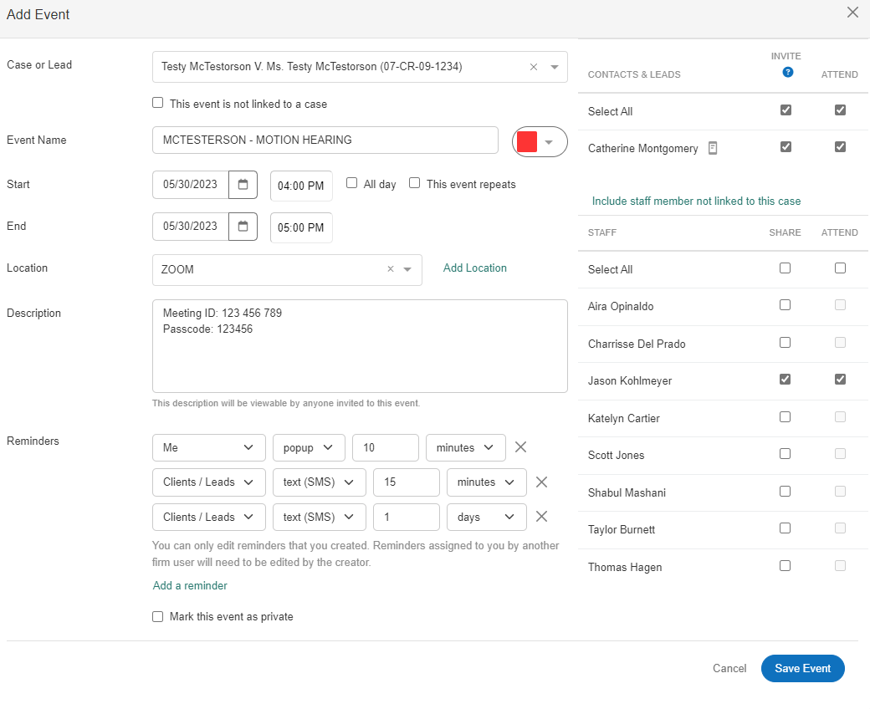

Client Calls / Meetings
- Uppercase and lowercase
- Always book for thirty minutes (unless instructed otherwise by attorney)
- If the event is in person, indicate whether it is the Mankato or Rochester Office
- Include a brief description of what the call is about but be aware the client can see this.
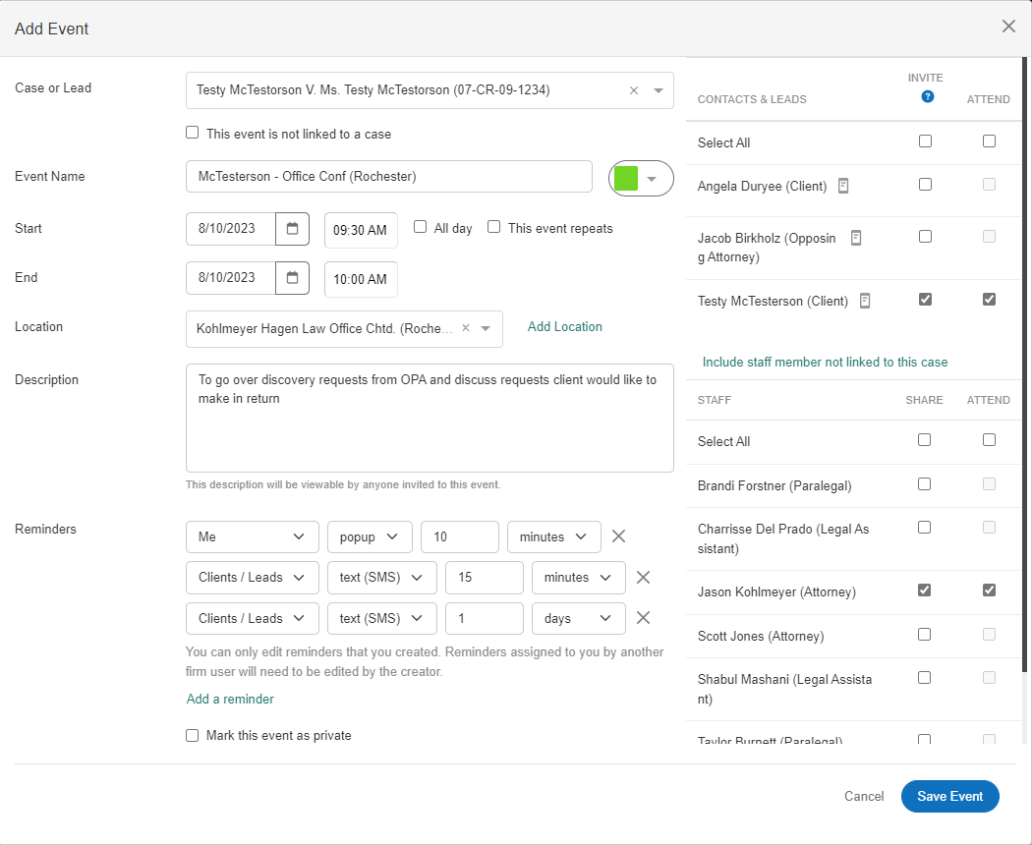

(see additional example below)

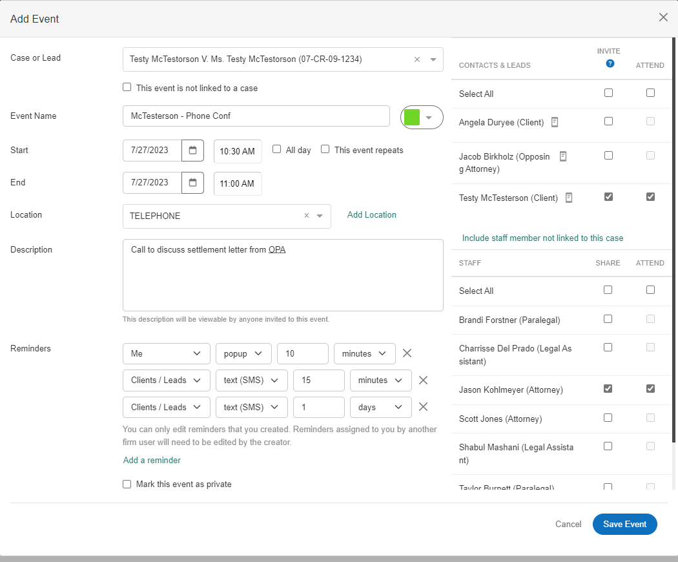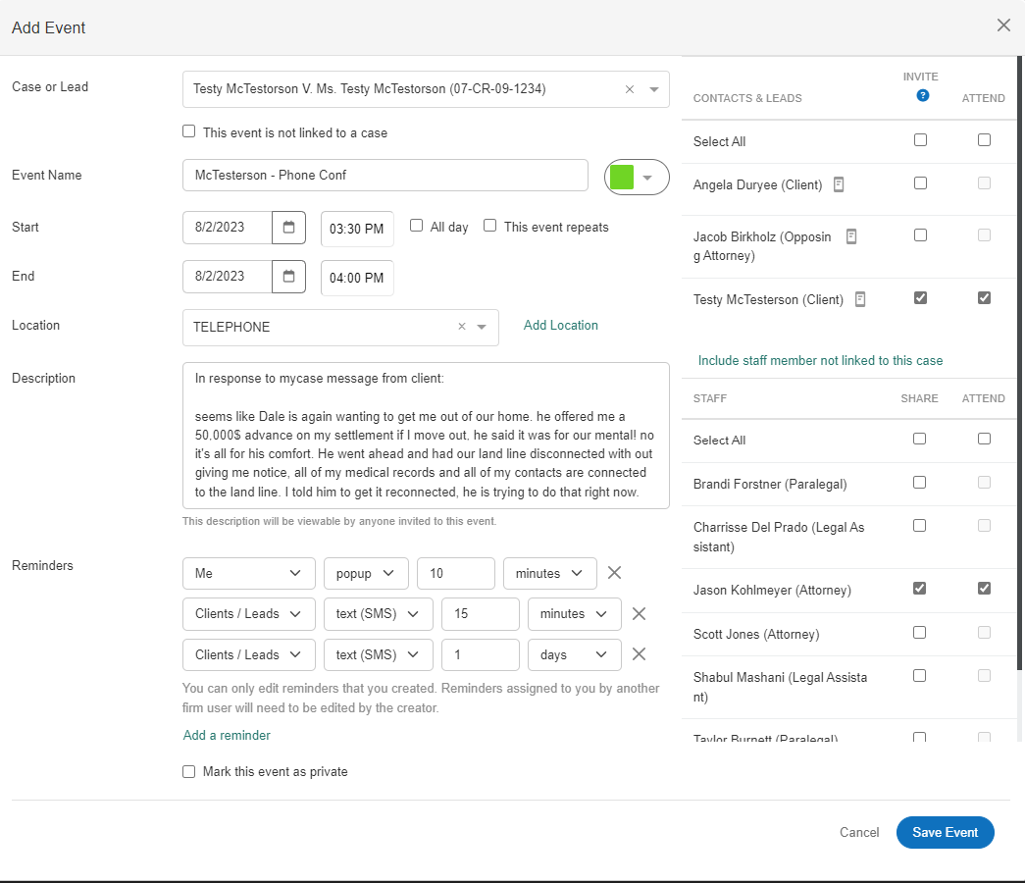

Mediation
- All uppercase
- Always book for 4 hours (unless otherwise directed by attorney or mediator)
- Distinguish if the mediation is actually in person (all parties going to the same location) or if it is via zoom with the client coming to our office.
  - If it is via zoom w/ client coming into office, note the office location in title
  - There may be situation where the mediation is via zoom and the client is not coming into the office, but instead will participate from their home. This is rare and would usually be specifically noted by the attorney
- Note the mediator and opposing attorney
- Be aware the client can see the description.
